KANE COUNTY
AFFORDABLE HOUSING FUND
RENTAL PROJECTS
2026 CALL FOR PROPOSALS

- Purpose

The purpose of this document is to solicit proposals from development entities seeking financing from the Affordable Housing Fund in order to:

- Improve the quality, expand the supply, and/or increase the diversity of affordable rental units available to lower-income households (less than or equal to 80% of area median income).

Proposals that address the following objectives are strongly encouraged:

- Creation of affordable workforce housing that is in reasonable proximity to employment centers;
- Creation of high-quality housing in areas of the County characterized by substandard housing, high-cost housing or generally have a negative neighborhood image;
- Reduction of the number of vacant/foreclosed properties that negatively impact neighborhoods; and
- Development of housing in accordance with the Kane-Elgin Consortium’s Consolidated Plan Priority #1: Affordable Housing; General Principles and Specific Housing Criteria (See Appendix F of Affordable Housing Fund General Guidelines).

- Available Funding/Real Estate

A combination of financing and real estate is available under this Call for Proposals. Approximately $1.8 million will be available to finance the development of affordable housing, and Elgin-based School District U-46 is making one piece of real estate available (at no cost) for rehabilitation/conversion back into a multi-family property. (See Appendix A for property information sheet.) For 2026, the Affordable Housing Fund has been capitalized by the City of Elgin, the City of St. Charles, and Kane County. The City of Elgin and Kane County have contributed federal funds from the U.S. Department of Housing and Urban Development, and the City of St. Charles has contributed funds from its Housing Trust Fund. These resources will be made available to eligible entities for housing development (or redevelopment) projects that meet the guidelines of the Affordable Housing Fund and are responsive to the evaluation criteria established herein. Pending the necessary board approvals, School District U-46 anticipates conveying the real estate to a developer at no cost in exchange for the necessary written agreements and/or security instruments to ensure completion of the redevelopment. Please note that financing awards will be based on needs presented in the application and required proforma. Financing terms will be structured to return funds to the Affordable Housing Fund in the greatest amount feasible. Finally, in the event additional funds become available, the sponsors of the Affordable Housing Fund reserve the right to award those funds to entities that respond to this Call for Proposals.

- Requirements/Scope of Service

All Project Sponsors are expected to have the capacity (either themselves or through the assembly of a well-qualified development team) to perform those actions necessary to achieve the project objectives. While those receiving financing under the Affordable Housing Fund will work under the general direction of the Development and Community Services Department, it is expected that each Project Sponsor will have personnel, experience, and expertise to ensure all necessary components of the housing project are completed in a timely manner. Project Sponsors should complete ALL appropriate sections of the Affordable Housing Fund proposal form to describe the details of the proposed project. All projects should conform to the applicable AHF guidelines.

- Submission Requirements

Proposals should be prepared using forms provided in this packet, and should be accompanied by project plans, financial information and other supporting documents noted on the submittal checklist. Incomplete proposals will be disqualified from consideration. Project Sponsors may submit additional information they deem pertinent. Any additional attachments to your submittal should be clearly labeled and identified on your submittal checklist. Plans provided in electronic format should be in an appropriate scale for printing on 11” x 17” paper.

- Review and Evaluation Criteria

Program assistance is made available through a Call for Proposals process. Proposals are sought in order to achieve the objectives of the Affordable Housing Fund, as outlined in the guidelines and this solicitation. All proposals should indicate the type of project(s) proposed, and amount/terms of financing requested. Proposals will be evaluated on a competitive basis and will be reviewed in accordance with the following criteria. Projects determined to be the most responsive will be selected and approved for financing.

- Financial Underwriting: Proposals must demonstrate that the project is not “economically feasible” without Program assistance and provide evidence the Project Sponsor has the financial ability to implement the project.
- Project Sponsor Qualifications: Consideration will be given to the development team’s qualifications to develop or redevelop distressed/vacant residential property into high-quality affordable housing, especially in the Kane County market area. Further, specific detail related to the qualifications and experience of the individual(s) identified as project manager(s) will be evaluated.
- Experience: Consideration will be given to the Project Sponsor’s track record of completing real estate development projects on time and within budget and their experience working with Federal funding (NSP, HOME, CDBG, etc.)
- Capacity: Consideration will be given to the Project Sponsor’s capacity, both in terms of anticipated work load, past performance in completing similar projects and ability to provide financial the guarantees/assurances necessary to ensure the successful completion of projects (including experience working with Federal funding (NSP, HOME, CDBG, etc.). As part of the review of financial capacity, we will ask for certification that the entity(ies) involved in the proposed project are in good standing, including but not limited to the full and timely payment of state or federal tax obligations.
- Project Design: Consideration will be given to projects that address Kane-Elgin Consortium Consolidated Plan Priority #1: Affordable Housing; General Principles and Specific Housing Criteria (See Appendix F to Affordable Housing Fund General Guidelines) and projects that meet or exceed county design requirements.
- Value: Priority will be given to Project Sponsors that are expected to provide a high-quality end product and service in relation to the cost of their proposals.

- Submission Deadline and Selection Process

All proposals are due to the Kane County Development and Community Services Department on July 6, 2026, at 4:00 pm. Proposals (including all applicable attachments) MUST be submitted electronically (in .pdf format) to OCR@co.kane.il.us (use of a One Drive or Google Docs link is also permissible). Documents must not be password protected in any way that would limit copying and/or printing. In addition to the required electronic copy, one ORIGINAL hard copy must be mailed or hand-delivered to:

Kane County Development and Community Services Department
Attn: Affordable Housing Fund
719 South Batavia Avenue
Geneva IL 60134

All materials submitted will be deemed property of Kane County. Proposals received after the deadline will be marked “Late Delivery” and returned to the sender. Following the submission deadline, the Development and Community Services Department reserves the right to request additional information from Project Sponsors and/or members of the development team, and reserves the right to verify any information provided. Proposals determined to be both complete and in conformance with fund guidelines will be evaluated by the Kane-Elgin HOME Commission on a competitive basis. (Financing and real estate made available under this call for projects by the City of Elgin may require additional municipal reviews and/or approvals.)

- Project Requirements, Funding Agreements, and Terms of Project Financing

Project Sponsors selected for financing will be afforded a reasonable amount of time to obtain and submit documentation that other approvals and/or commitments have been secured. The county will not issue final commitments until all other financing is in place and the project is ready to proceed.

Project Sponsors are expected to enter into funding agreements, which outline various project and program requirements, including those involving environmental review, contracting/procurement, and recordkeeping. No work may begin prior to the execution of the agreement. Once projects are underway, Project Sponsors are expected to administer/oversee their projects (either with their own personnel or with contracted consultants), submit periodic performance reports to document progress, and request funding disbursements as needed for the payment of eligible project expenses.

Assistance provided will be secured by a mortgage and a covenant running with the land or a deed restriction.
Program assistance may be subordinated to private or other financing if determined necessary for project implementation, upon approval from the County. Assistance generally will be non-recourse with recovery rights limited to the encumbered collateral and any income therefrom.

- Limitations

The Development and Community Services Department reserves the right to enter into funding agreement(s) with the Project Sponsor(s) whose proposal(s), in the judgment of the Kane-Elgin HOME Commission, best addresses AHF objectives. The selection of a project, however, in no way obligates the Office of Community Reinvestment to enter into a funding agreement with the selected Project Sponsor. The final selection will not require competitive bidding.
- Questions/Clarification

The staff of the Development and Community Services Department is available to answer questions regarding the Affordable Housing Fund in general, and the requirements/guidelines discussed herein. Please contact Chris Dall, Assistant Director, at 331-312-9231 or dallchristopher@kanecountyil.gov, or Toni Mallett, Community Development Program Manager, at 630-444-1076 or malletttoni@kanecountyil.gov for further assistance.

KANE COUNTY
AFFORDABLE HOUSING FUND
RENTAL PROPOSAL CHECKLIST AND COVER SHEET

PROJECT SPONSOR NAME:

Instructions: After completing the forms in this packet, including all sections and signature pages, use this checklist as a guide to organize and assemble your proposal. Indicate the attachments that are included in your submittal by checking the box in the “Document Attached” column. Some items may not be applicable to your project. Please be sure to review this checklist carefully, and include any and all attachments based on the responses you provided in the application forms. All documents should be labeled with a LETTER, and organized accordingly in alphabetical order behind the completed application forms.

Attachment Name | Document Attached
- Preliminary Project Schedule
- Project cost estimates
- Project Pro-forma (per AHF Guidelines for Rental Projects)
- Preliminary plans, schematics, renderings and/or other documents presenting proposed development. (Must be provided in electronic format and in an appropriate scale for printing on 11” x 17” paper.)
- Construction Cost Certification (demonstrating costs are reasonable)
- Copies of all Funding Award Letters/Notices referenced in budget document
- Summary of Completed Projects – please check boxes for each item to ensure you have included required information about your completed projects
  - Name and location of projects completed by Project Sponsor (last 3 years only)
  - Relevant details including cost of project, number of units, housing type (rental, owner, special needs, mixed use, etc.), target populations
  - Identify any sources of public financing used and contact names/telephone numbers for each government agency. (County may contact agencies to confirm the quality of work performed by the Project Sponsor.)
  - Date of project completion
  - Photos of completed projects
- Summary of Projects currently in Predevelopment, Preconstruction, and Construction – please check boxes for each item to ensure you have included required information about your completed projects
- Name and location of projects
- Relevant details including cost of project, number of units, housing type (rental, owner, special needs, mixed use, etc.), target populations
- Identify any sources of public financing used and contact names/telephone numbers for each government agency
- Expected date of project completion
- Market Study/Assessment of demand for project
- Market Analysis/Appraisal for property acquired or to be acquired for project. (Because my project is a scattered site project for which an address(es) is/are not yet available, this item is not applicable .)
- Listing of all units within subject property, noting unit occupancy/vacancy and copies of General Information Notice(s) sent to existing tenants. (Because my project is new construction, this item is not applicable .)
- Housing Authority/Instrumentality jurisdiction: Letter from Housing Authority documenting jurisdiction for it, or its instrumentality, to participate in the project; if the project is outside Aurora and Elgin, documentation is required showing State of Illinois approval of jurisdiction. (Because my project does not involve a Housing Authority or HA instrumentality, this item is not applicable .)
- Current 501(c)(3) or 501(c)(4) Letter of Determination and most recent IRS form 990
- Board Resolution authorizing application for financing
- Flowchart or diagram of the developer/partnership structure for the project
- Flowchart or diagram of the financing/project ownership structure for the project
- Project Sponsor Financial statements - year to date
- Project Sponsor Financial statements - last 3 years (audited) (Because applicant is For Profit business, last 3 years of un-audited financial statements are attached.)
- Additional attachment:
- Additional attachment:
- Additional attachment:
- Additional attachment:
- Additional attachment:

By signing this completed checklist, I attest that I have included the indicated documentation, and provided complete and accurate information to Kane County in support of this proposal.

______________________________________
Signature Date

Name/Title (Printed)

KANE COUNTY
AFFORDABLE HOUSING FUND
RENTAL PROJECT PROPOSAL

PROJECT SPONSOR CERTIFICATIONS

The Project Sponsor certifies that all information furnished in/with this proposal is provided for the purpose of obtaining financial assistance under the Affordable Housing Fund and is true and complete to the best of the Project Sponsor’s knowledge and belief. If any information provided herein changes following submission of this proposal, the Project Sponsor agrees to notify Kane County’s Office of Community Reinvestment immediately. The Project Sponsor understands and agrees that if false information is provided in/with this proposal, which has the effect of increasing the Project Sponsor’s competitive advantage, the Kane County Office of Community Reinvestment may disqualify the Project Sponsor and deem the Project Sponsor ineligible to receive any funds in the future.

Verification of any of the information contained in/with this proposal may be obtained from any source named herein. Submission of this proposal shall constitute the Project Sponsor’s authorization for the Kane County Office of Community Reinvestment to undertake such investigations as it deems necessary to determine the accuracy of this proposal and the Project Sponsor’s suitability for financing from Kane County’s Office of Community Reinvestment. The Kane County Office of Community Reinvestment reserves the right to require financial statements (audited or unaudited) of each development team member as part of its underwriting process.

The Project Sponsor will at all times indemnify and hold harmless Kane County against all losses, costs, damages, expenses and liabilities of any nature directly or indirectly resulting from, arising out of or relating to the Kane County’s acceptance, consideration, approval, or disapproval of this proposal and the issuance or non-issuance of funds herewith.

The Kane County Office of Community Reinvestment retains the right to reject any and all proposals, and, in its sole determination, to waive minor irregularities. Further, the Project Sponsor acknowledges by execution of this certification that the Kane County Office of Community Reinvestment will review this proposal and reach its determination with the fullest discretion allowable by law.

The Project Sponsor further certifies that neither it, its principals, nor members of its development team are presently debarred, suspended, proposed for disbarment, declared ineligible or voluntarily excluded from HUD programs. Additionally, said parties are in good standing on state and federal tax obligations.

IN WITNESS WHEREOF, the undersigned, being duly authorized, has caused this document to be executed in its name on the day of , .

Legal Name of Project Sponsor:
Signature of Authorized Party:
Name: (please type)
Title:
Date:

THIS PAGE MUST BE SIGNED IN ORDER FOR THE COUNTY TO ACCEPT YOUR SUBMITTAL

PROJECT SPONSOR INFORMATION

Project Sponsor Name:
Project Name:
Federal ID #: |  |  |  |  | DUNS # (if available):
Mailing Address including City, State and Zip:
Contact Person:
Telephone Number: |  |  |  |  | Email Address:
Not-For-Profit Organization For-Profit Organization
Is your organization a Community Housing Development Organization (CHDO)? Yes No
Are you seeking financing from Low Income Housing Tax Credits Yes No
Please indicate the nature of work involved in your proposed project:
Check all that apply: | Acquisition of real estate |  |  | Rehabilitation of existing housing
 | New construction |  |  | Conversion to residential
Total Cost of Project |  |  | $ |  |  | Total # of Housing Units in the Project
AHF Amount Requested |  |  | $
Does this proposal involve the development of 4 South Gifford Street in Elgin offered by School District U-46 and described in Appendix A of the AHF application materials? Yes No

DEVELOPMENT TEAM INFORMATION

Role | Name of Entity | Existing | To Be Formed
Co-Sponsor
Owner
- General Partner
- Limited Partner
- Limited Partner
Architect
General Contractor
Attorney
Property Management
Other:
Other:

PROJECT NARRATIVE/PLANS

Provide an answer to every question. Typing “See Attached” is not an acceptable response.
IF THE QUESTION IS NOT APPLICABLE TO YOUR PROPOSED PROJECT, PLEASE WRITE “N/A”.

- Provide a detailed abstract of proposed project or development.

limit 4,000 characters

- Describe the project control structure from initial stages through construction and ongoing management, including partnerships or entities that are still to be formed.

limit 4,000 characters

- Will the project target a particular population(s)? Yes No
If yes, please describe all that are applicable (e.g. elderly, disabled, homeless, small/large families, etc.)

limit 4,000 characters

Describe supportive services to be provided, if any, including a detailed description of who will deliver these services. Attach copies of draft service agreements to be entered into with the service providers. Please include the name/contact information for the agencies that will provide services.

limit 4,000 characters

- Provide details about the bedroom count and income limits associated with the units proposed.

# of Bedrooms | # of Units
# of Bedrooms | 30% limit | 50% limit | 60% limit | 80% limit | Market Rate
TOTAL

If there is an employee unit included in the project, please describe whether this unit will be income restricted and provide any further information about how this unit is included in the total unit count.

limit 4,000 characters

- Will the project utilize Project-Based Housing Choice Vouchers? Yes No
If yes, please describe the number, dollar amount and duration of Project-Based Housing Choice Vouchers.

limit 4,000 characters

- Is the property subject to this proposal currently occupied by:
Residential Renter Yes No
Residential Owner Yes No
Business Yes No
If yes to any of the above, please describe any plans and timelines for project transition. Please note that failure to provide notice under the Uniform Relocation Act to any current occupants concurrent with submission of this proposal to Kane County may jeopardize your ability to receive financing under the Affordable Housing Fund program.

limit 4,000 characters

- Provide a description of how the proposal addresses the Kane-Elgin Consortium’s Consolidated Plan Priority #1: Affordable Housing; General Principles and Specific Housing Criteria (See Appendix F to Affordable Housing Fund General Guidelines), with specific attention to the location and design of the project in accordance with county design requirements.

limit 4,000 characters

- Provide a description of current site control for the proposed project site.

limit 4,000 characters

PROJECT SPONSOR EXPERIENCE/QUALIFICATIONS

- Describe the relevant experience/qualifications of the Project Sponsor.

limit 4,000 characters

- List the name and title of the individual(s) who will manage the project.

limit 4,000 characters

- Please disclose any investigation underway regarding any member of the development team.

limit 4,000 characters

- Complete a DEVELOPMENT TEAM MEMBER NARRATIVE for each member listed on the Development Team. The narrative should address the experience and qualifications of the team member/firm, and any principals or staff that will be assigned to the project.

4.1 ROLE:
ENTITY NAME: | CONTACT PERSON:
ADDRESS: | PHONE: ( ) - | EMAIL:
limit 4,000 Characters

4.2 ROLE:
CONTACT PERSON: | CONTACT PERSON:
PHONE: ( ) - | PHONE: ( ) - | PHONE: ( ) -
limit 4,000 Characters

4.3 ROLE:
CONTACT PERSON: | CONTACT PERSON:
PHONE: ( ) - | PHONE: ( ) - | PHONE: ( ) -
limit 4,000 Characters

4.4 ROLE:
CONTACT PERSON: | CONTACT PERSON:
PHONE: ( ) - | PHONE: ( ) - | PHONE: ( ) -
limit 4,000 Characters

4.5 ROLE:
CONTACT PERSON: | CONTACT PERSON:
PHONE: ( ) - | PHONE: ( ) - | EMAIL:
limit 4,000 Characters

4.6 ROLE:
CONTACT PERSON: | CONTACT PERSON:
PHONE: ( ) - | PHONE: ( ) - | PHONE: ( ) -
limit 4,000 Characters

4.7 ROLE:
CONTACT PERSON: | CONTACT PERSON:
PHONE: ( ) - | PHONE: ( ) - | PHONE: ( ) -
limit 4,000 Characters

4.8 ROLE:
CONTACT PERSON: | CONTACT PERSON:
PHONE: ( ) - | PHONE: ( ) - | PHONE: ( ) -
limit 4,000 Characters

- Has the assembled development team worked together previously on similar projects? Yes No
If yes, please describe the results of this relationship by citing examples of prior development. If no, describe why/how these parties have been selected.

limit 4,000 characters

SOURCES AND USES OF FUNDS

Please list all sources of funds including dollar amount and timing of availability. List the proposed use of each source of funds, and include copies of firm commitment letters with all terms and conditions for all mortgages, grants, bridge (interim) loans and investment tax credits (historical, low-income, if applicable). Please do not use acronyms.

Sources of Permanent Financing
List in order of position proposed.

 | Financial Institution: | Interest Rate: | Date funds available:
 | Financing Program: | Amortization Period: | Status of financing:  Status Documentation Attached
 | Amount: | Loan Term: | Status of financing:  Status Documentation Attached
 | Contact: | Annual Debt Service: | Affordability period or other financing restrictions:
 | Phone: | Debt service position: | Affordability period or other financing restrictions:
 | Financial Institution: | Interest Rate: | Date funds available:
 | Financing Program: | Amortization Period: | Status of financing:  Status Documentation Attached
 | Amount: | Loan Term: | Status of financing:  Status Documentation Attached
 | Contact: | Annual Debt Service: | Affordability period or other financing restrictions:
 | Phone: | Debt service position: | Affordability period or other financing restrictions:
 | Financial Institution: | Interest Rate: | Date funds available:
 | Financing Program: | Amortization Period: | Status of financing:  Status Documentation Attached
 | Amount: | Loan Term: | Status of financing:  Status Documentation Attached
 | Contact: | Annual Debt Service: | Affordability period or other financing restrictions:
 | Phone: | Debt service position: | Affordability period or other financing restrictions:
 | Financial Institution: | Interest Rate: | Date funds available:
 | Financing Program: | Amortization Period: | Status of financing:  Status Documentation Attached
 | Amount: | Loan Term: | Status of financing:  Status Documentation Attached
 | Contact: | Annual Debt Service: | Affordability period or other financing restrictions:
 | Phone: | Debt service position: | Affordability period or other financing restrictions:
 | Financial Institution: | Interest Rate: | Date funds available:
 | Financing Program: | Amortization Period: | Status of financing:  Status Documentation Attached
 | Amount: | Loan Term: | Status of financing:  Status Documentation Attached
 | Contact: | Annual Debt Service: | Affordability period or other financing restrictions:
 | Phone: | Debt service position: | Affordability period or other financing restrictions:
 | Financial Institution: | Interest Rate: | Date funds available:
 | Financing Program: | Amortization Period: | Status of financing:  Status Documentation Attached
 | Amount: | Loan Term: | Status of financing:  Status Documentation Attached
 | Contact: | Annual Debt Service: | Affordability period or other financing restrictions:
 | Phone: | Debt service position: | Affordability period or other financing restrictions:
 | Financial Institution: | Interest Rate: | Date funds available:
 | Financing Program: | Amortization Period: | Status of financing:  Status Documentation Attached
 | Amount: | Loan Term: | Status of financing:  Status Documentation Attached
 | Contact: | Annual Debt Service: | Affordability period or other financing restrictions:
 | Phone: | Debt service position: | Affordability period or other financing restrictions:
 | Financial Institution: | Interest Rate: | Date funds available:
 | Financing Program: | Amortization Period: | Status of financing:  Status Documentation Attached
 | Amount: | Loan Term: | Status of financing:  Status Documentation Attached
 | Contact: | Annual Debt Service: | Affordability period or other financing restrictions:
 | Phone: | Debt service position: | Affordability period or other financing restrictions:

Uses of Permanent Financing

Posit-ion | Acquisition Costs  (A) | Construction/ Rehab (B) | Developer Fee (C) | Development Costs (D) | Financing Costs (E) | Other Costs (F) | Totals
1 | $ | $ | $ | $ | $ | $ | $
2 | $ | $ | $ | $ | $ | $ | $
3 | $ | $ | $ | $ | $ | $ | $
4 | $ | $ | $ | $ | $ | $ | $
5 | $ | $ | $ | $ | $ | $ | $
6 | $ | $ | $ | $ | $ | $ | $
7 | $ | $ | $ | $ | $ | $ | $
8 | $ | $ | $ | $ | $ | $ | $
TOTALS | $ | $ | $ | $ | $ | $ | $

Low Income Housing Tax Credits

Will this project be financed using Low Income Housing Tax Credits? Yes No

Type of Credit: 4% (or) 9%
Allocation Status: | Reservation Date:
Annual Tax Credit: $ | Equity to be Raised: $ $ | Owner’s Equity: $
Tax Credit Syndicator: | Address: | Phone:
Have you received a commitment from the tax credit syndicator? Yes No (If Yes, please attach)

Sources of Construction Financing
Source of Financing | Amount | Contact Name and Phone Number | Date available | Documentation Attached & Labeled
 | $
 | $
 | $
 | $
 | $
 | $
 | $
 | $
 | $
 | $

RENTAL PROJECT INFORMATION
For each cost category, you must enter the total cost, and mark whether you are requesting to use Affordable Housing Funds for that item.

ACQUISITION COSTS | TOTAL COST | PROPOSED USE OF AHF
Land Acquisition Costs (Enter $0 in Total Cost column if this proposal will utilize School District U-46’s 4 South Gifford Street property.) | $
Land Acquisition Closing Costs (title, recording, etc.) | $
Building Acquisition Costs | $
Building Acquisition Closing Costs (title, recording, etc.) | $
Other: | $
Acquisition Total (A) | $

CONSTRUCTION/REHAB COSTS
Site Work | $
Demolition | $
Rehabilitation/Construction | $
Equipment | $
General Requirements | $
Contractor’s Overhead | $
Contractor’s Profit | $
Bonding Fee | $
Builder’s Risk Insurance | $
Other: | $
Subtotal | $
Construction Contingency ( %) | $
Construction/Rehab Total (B) | $
Developer’s Fee ( % of Acquisition and Construction/Rehab) (C) | $

DEVELOPMENT COSTS
Real Estate Matters
Partnership Formation | $
Subdivision | $
Other: | $
Project Design
Architectural (Design) | $
Architectural (Supervision) | $
Cost Estimate | $
Engineering | $
Value Engineering | $
Site Investigation | $
Other: | $
Project Planning
All Fees | $
Permits | $
Appraisal (pre-purchase) | $
Appraisal (post-rehab) | $
Environmental Study | $
Lead Based Paint Inspection | $
Market Study | $
Survey | $
Utility Fees | $
Other: | $
Marketing/Leasing
Marketing | $
Operating Reserve | $
Other: | $
Development Total (D) | $
FINANCING COSTS | TOTAL COST
Tax Credits
Tax Credit Fee | $
Tax Credit Counsel | $
Cost Certification | $
Other: | $
Other: | $
Tax-Exempt Bond Financing
Bond Counsel | $
Underwriter’s Fee | $
Other: | $
Other: | $
Conventional Loans
Construction Loan Origination Fees | $
Construction Loan Legal Fees | $
Permanent Loan Origination Fees | $
Permanent Loan Legal Fees | $
Loan Recordation Taxes/Fees | $
Other: | $
Other: | $
Other Loans
Legal Fees | $
Loan Recordation Taxes/Fees | $
Other: | $
Other: | $
Construction Period Interest | $
Financing Total (E) | $

OTHER COSTS
Relocation | $
Other: | $
Other Costs Total (F) | $
TOTAL DEVELOPMENT COST (A+B+C+D+E+F) = | $

Project Income/Expenses:
Provide the following information regarding rental project income and expenses for the first year of operation following construction/rehabilitation. We expect that these figures will be used as a baseline in your pro-forma.

Unit Mix and Project Income:

# of Bedrooms | # of Units | Average  Square Feet | Gross Monthly  Rent/Unit | Allowance for  Tenant-Paid Utilities* | Net Monthly  Rent/Unit
0 |  |  | $ | $ | $
1 |  |  | $ | $ | $
2 |  |  | $ | $ | $
3 |  |  | $ | $ | $
4 |  |  | $ | $ | $
TOTAL

* See Appendix A of the “Guidelines for Rental Projects” for guidance regarding establishing a utility allowance schedule.

Annual Income:

Income Source | Amount
 | $
 | $
 | $

Annual Expense:

Annual Administrative Expenses
Expense Item | Amount
Management Fee | $
Legal/Accounting | $
Administrative | $
Advertising | $
Other: | $
Other: | $
Other: | $
Total Administrative | $
Annual Operating Expenses
Expense Item | Amount
Natural Gas (& other fuel) | $
Electricity | $
Water/Sewer | $
Trash Removal | $
Janitorial | $
Exterminating | $
Other: | $
Other: | $
Other: | $
Total Operating | $
Annual Maintenance Expenses
Expense Item | Amount
Building Maintenance | $
Ground Maintenance | $
Security | $
Decorating | $
Replacement Reserve | $
Other: | $
Other: | $
Other: | $
Total Maintenance | $
Annual Taxes and Insurance
Expense Item | Amount
Real Estate Taxes | $
Insurance | $
Other: | $
Other: | $
Total Taxes and Insurance | $
Annual Resident Services Expenses
Expense Item | Amount
Cost of Supportive Services (for this project only) | $
Other: | $
Other: | $
Total Resident Services | $
Total Annual Project Expenses | $

Project Pro-forma:
All rental proposals must be accompanied by a project pro-forma, which must cover at least 30 years. When preparing the pro-forma, Project Sponsors must keep factors relevant to project feasibility (i.e., owner rate of return, vacancy rate, per-unit development costs, etc.) reasonable in order to minimize the amount of Affordable Housing Funds requested. The pro-forma must also include rent levels, market vacancies and operating expenses. It should also specify the consequences of tax benefits, if any, and any other assumptions used in calculating the project cash flow. Upon the completion of construction, a rental project, a minimum of 65% of net operating income (NOI) must be available for debt service (DS); and/or the operation of the project must result in a minimum debt coverage ratio (DCR) of 1.15 on an annual basis calculated as follows: NOI/DS=DCR. The County will evaluate the pro-forma to ensure it a project that meets a minimum DCR for the term of the affordability requirements, or longer if other funding sources require longer affordability terms.

In evaluating proposals for funding, a “subsidy layering analysis” will be conducted to certify that the County is not investing any more Affordable Housing Funds in combination with other governmental and/or non-governmental assistance than is necessary to make projects feasible.

Below are the default assumptions that applicants should use in preparing their project pro-forma. Should you choose to modify the default vacancy or growth rates, please provide a justification.

Vacancy Rate | 7%
Growth Rate (Rent) | 2%
Growth Rate (Other Income) | 2%
Growth Rate (General Expenses) | 3%
Growth Rate (Real Estate Taxes) | 4%
Per unit Annual Replacement Reserves | $400
Per unit Monitoring Fee (every three years) | $100
*Clearly label all debt repayment and positioning of debt
*Clearly identify cash flow repayment
Provide justification if alternative assumptions are used in your proforma:

APPENDIX A
Property Information Sheet

4 South Gifford Street, Elgin Illinois 60120 (PIN: 06-13-326-010)
(Referred to herein as the “subject property”.)

Subject property identified by * on the Elgin zoning map excerpt below.
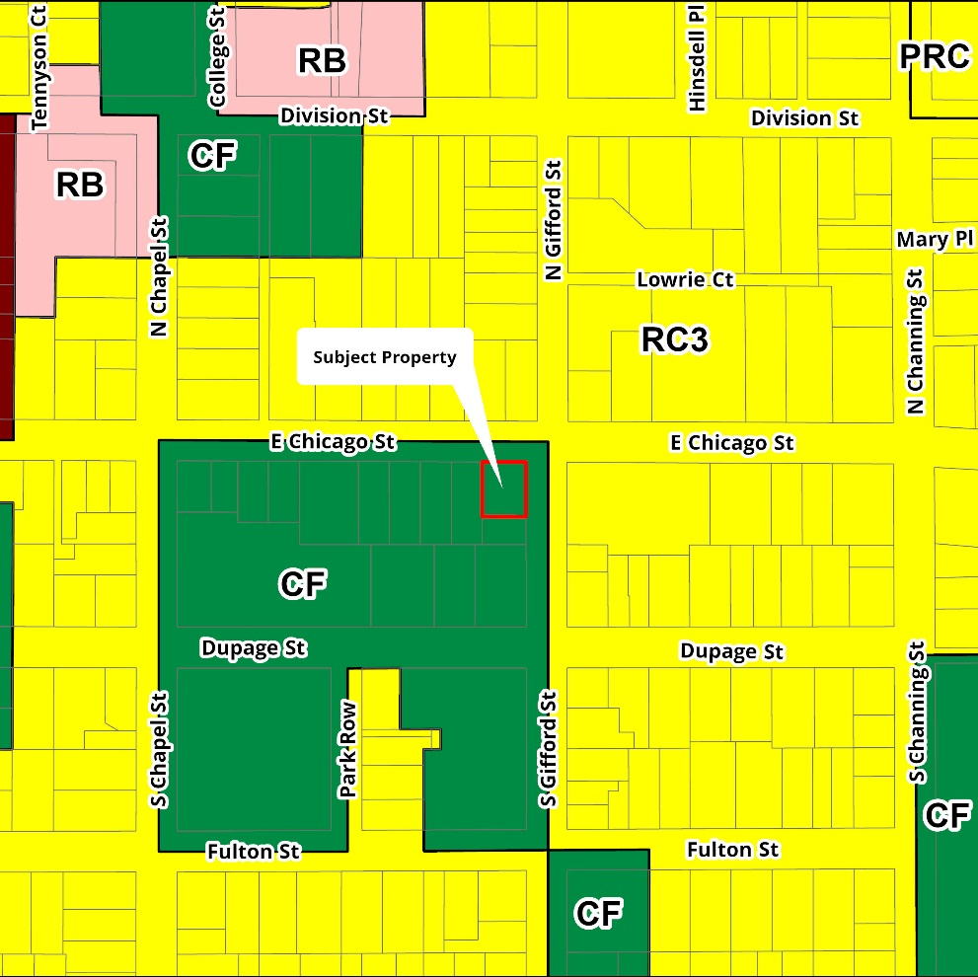
*

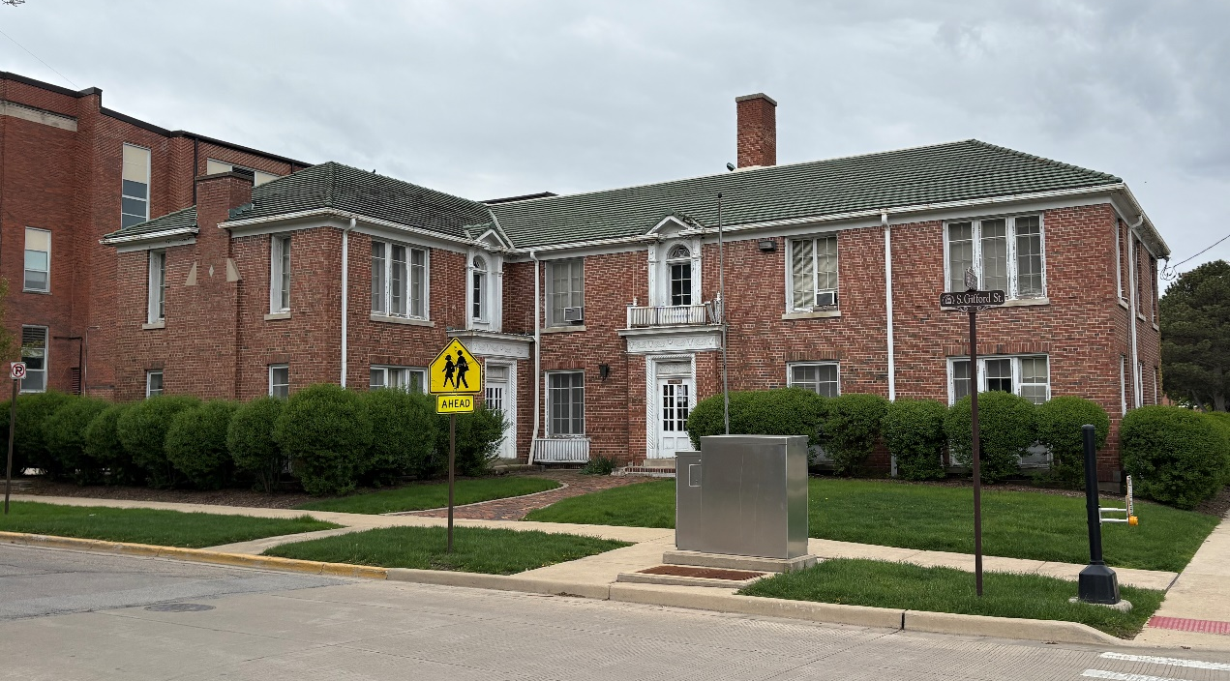
Former Apartment Building at 4 South Gifford Street
(Looking southwest)
General Information:
- The “subject property” consists of one parcel located at the southwest corner of East Chicago and South Gifford Streets in the City of Elgin. The historic two-story building on the property was built in 1925 by Fred W. Juby and was known as the Juby Apartment Building. It was designed by prominent local architect Ralph Abell, son of notable Elgin architect William W. Abell. It is considered an excellent example of Georgian-style architecture and is listed as a “contributing” structure within the Elgin Historic District established under municipal code in 1981 and placed on the National Register of Historic Places in 1983.
- In 1959, the property was purchased by School District U-46, which converted it for use as administrative offices. The property is currently vacant. The school district will consider transferring the property (at no cost) to a qualified developer for conversion back to multi-family housing. Developers should indicate their interest in the property via the Affordable Housing Fund application process.
- The subject property is currently Zoned CF – Community Facility. The successful developer will be expected to work with the City of Elgin to obtain the necessary zoning approvals and/or variances.
- Rehabilitation work must adhere to historic preservation standards. Exterior rehabilitation work will be subject to the review and approval of the Elgin Heritage Commission’s Design Review Subcommittee.
- Early in the stages of developing an application, prospective applicants are encouraged to discuss their plans for development of the site with the City of Elgin (see contact numbers below).

Resources:
- Elgin Planning and Zoning: https://elginil.gov/90/Planning-and-Zoning
- Design Guideline Manual: https://elginil.gov/89/Historic-Preservation#docaccess-0f5a9aacf4e721c60ad47f3bdb3b712ef7c25631cf94f6522b738e46987a8e5d
- Certificate of Appropriateness: http://www.cityofelgin.org/DocumentCenter/View/105

City of Elgin Contact Numbers:
- Planning and Zoning: (847) 931-5943
- Historic Preservation: (847) 931-6004
- Schedule a Visit to the Subject Property: (847) 931-5679

