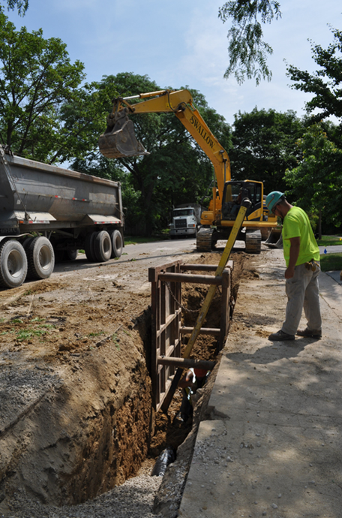
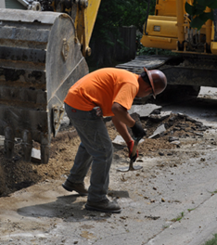

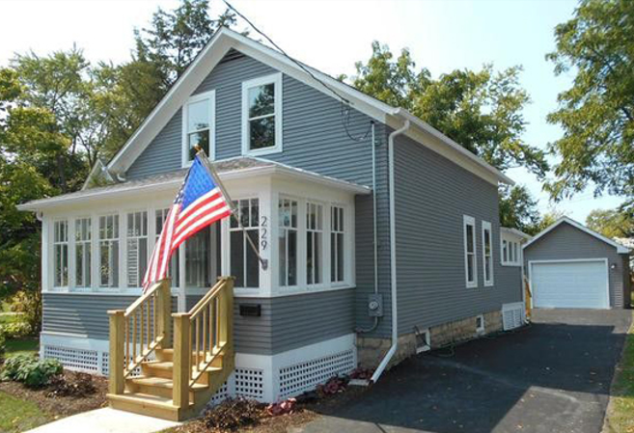
C
KANE COUNTY
DEVELOPMENT & COMMUNITY SERVICES
719 S BATAVIA AVENUE, BLDG A
GENEVA, ILLINOIS 60134
Community Development Fund
Application Instructions

Deadline for Submission: Wednesday, March 18, 2026, 4:00 pm
over Page

KANE COUNTY
COMMUNITY DEVELOPMENT FUND
2026 APPLICATION INSTRUCTIONS

- GENERAL GUIDANCE

This packet contains information necessary to apply for financial assistance from the Kane County Community Development Fund (CDF). The program supports a wide array of projects and activities that improve the quality of life for low- and moderate-income Kane County residents. In this application cycle, the County is specifically seeking proposals that involve Neighborhood Improvement Projects. Prior to preparing an application, applicants should review the Kane County Community Development Fund Program Guidelines, including the General Guidelines as well as the Supplemental Guidelines applicable to these types of activities. The guidelines provide information related to applicant eligibility, eligible activities, and the various rules and regulations that affect activities assisted under the Community Development Fund. It is important that applicants have the capacity and processes in place to successfully comply with all federal requirements associated with the Community Development Fund.

- AVAILABLE FUNDING

The County has been notified of its annual federal allocation for Fiscal Year 2026, and expects to make approximately $1,260,000 in CDF funds available through this application cycle. The County does not impose a uniform minimum or maximum on award amounts under the Community Development Fund. Rather, it seeks to provide only the amount of “gap” funding needed by Project Sponsors after funding from all other sources has been taken into account. Applicants are discouraged from relying exclusively on funding from the Community Development Fund for their projects.

- PREPARING AN APPLICATION

Applicants seeking CDF funds must use application forms and materials provided by Kane County. Note that separate forms are provided for the two types of projects sought in this application cycle. Applicants should provide complete and concise answers to all application questions and include all requested information in order to be considered for funding. Each application packet includes a “Coversheet/Checklist” that identifies the application forms and supporting documentation required. These materials must be assembled and labeled according to the instructions provided on the checklists.

Applications should include complete and sound plans for accomplishing the project or program proposed. All components necessary to do so should be identified and described in the application. The estimated cost of each component should be included in the project budget. Proposals that overlook or fail to include goods or services critical to the project or program will be deemed incomplete and/or infeasible. Applicants may choose to complete certain aspects of their project using their own employees or may procure those services from outside vendors. The qualifications of key employees responsible for carrying out the project or program should be described, and the procurement of any services needed should be incorporated into the project plan and schedule.

Applicants may propose multiple programs or projects, but must complete a separate application for each such program or project.

- STAFF CONSULTATION

Applicants are encouraged to consult the staff of the Kane County Development & Community Services Department prior to preparing an application for CDF funding. Federal rules, regulations, and requirements may affect project eligibility or impact how a particular project is implemented. This is especially true where construction projects are concerned. County staff are available to assist applicants during the planning stage in order to avoid compliance problems later.

- SUBMISSION INSTRUCTIONS AND DEADLINE

Applications for Community Development funds are due at 4:00 pm, Wednesday, March 18, 2026. All applications must be submitted electronically to ocr@co.kane.il.us. The completed coversheet/ checklist, application forms, and supporting documents (exhibits) should be assembled in the proper order. If possible, combine the items into one pdf prior to submission. If the combined packet is too large, it can be broken down into multiple pdfs and submitted via multiple emails. Please do not submit the program guidelines, application instructions, or other documents that do not relate to your project type. Applicants should retain these materials for future reference.

- EVALUATION CRITERIA

CDF funds are awarded on a competitive basis. In addition to being evaluated for eligibility, completeness, and readiness to proceed, projects will be evaluated for their effectiveness at addressing a Consolidated Plan objective, the extent to which they will benefit the community (particularly lower-income residents), and their leverage of other resources. Applicants will be evaluated for their financial capacity and stability, as well as their experience, track record, and staff capacity to undertake and successfully complete the project they propose. Applicants must completely answer all questions in the application and include all requested information in order to be considered for funding. Projects that can be completed in the next twelve months will be given preference.

- LIMITATIONS

In the course of evaluating applications for CDF funds, Kane County may, in its sole discretion, request additional information from applicants and verify any/all information provided in/with applications. The County reserves the right to reject any/all proposals and waive informalities provided such a waiver does not violate any federal, state, or local law or regulation, and is in the best interest of the County. The County reserves the right to enter into funding agreements with the applicant(s) whose proposal(s), in the judgment of the County, best address County objectives. The selection of a particular project, however, in no way obligates the County to enter into a funding agreement with that applicant.

- QUESTIONS/CLARIFICATION

The staff of the Kane County Development & Community Services Department are available to answer questions regarding application procedures, project eligibility requirements, and the Community Development Fund in general. If you need assistance, or have questions, please don't hesitate to contact Chris Dall at 331-312-9231 or dallchristopher@kanecountyil.gov.

Application Deadline:
Wednesday, March 18, 2026 @4:00 pm
(Electronic Submittals Only)

Submit to the Kane County Development & Community Services Department
Email: ocr@co.kane.il.us

